ROUTE 66 SCHOLARSHIP PROGRAM
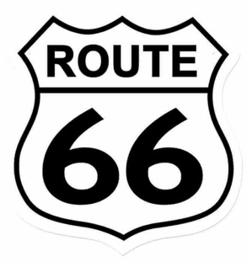

An invitation for students in K – 12 to promote
The Mother Road
Early in my teaching career, I incorporated our schools first and only computer connected to the internet by having my students bicycle 2,000 miles in the back of the classroom aboard an exercise bicycle while learning all about Route 66. At the time, I knew very little about America’s most popular highway, but managed to connect that year with Route 66 advocates such as Michael Wallis, Angel Delgadillo, Bobby Troup, Shellee Graham, and Chicago Mayor Daley.

Almost 20 years later, I launched The Route 66 Podcast, featuring talks with people living and working along The Mother Road. Episodes feature talks with individuals living and working along The Mother Road, including Route 66 pioneers, popular business and motel owners, and poular authors related to the road.

The recent nationwide closure of schools has put a new dimension on teaching, and despite the many challenges, I’ve been encouraged to see students become excited by going above and beyond what is expected of them during a time of remote instruction. This includes students taking a concept I may have introduced by video and recreating the activity or attempting a completely different approach. The key to student success during this unprecedented is to actively engage students in an idea that encourages creative, hands on learning.

As an educator and host of the Route 66 Podcast, I would like to invite all students in grades K – 12 to dig deep into their creative energy by submitting an entry in the Route 66 Podcast Scholarship program. Awards ranging from $25 - $100 will be given to students to deepen their knowledge about Route 66 by submitting a project based on promoting and preserving the road often referred to as America’s Main Street. Applicants are encouraged to listen to past episodes of The Route 66 Podcast for ideas and topics that may be of interest to as a starting point. Students do not need to live along Route 66 but simply have an interest in promoting Route 66.
The guidelines for this event are purposely open ended to accommodate all interested students and applicants are encouraged to be as creative as possible, as long as the finished product meets the criteria of both promoting and preserving historic Route 66. Projects may include, but are not limited to the following submissions:
- Art Work
- Photographs
- Crafts
- Interviews
- Performance
- Music
- Videos
- PowerPoint, Prezi, Canva, Google Slides,
- Multimedia Presentation
Art work, photographs, and crafts need to physically submitted to Route 66 Podcast at 3840 Taylortown Road, Furlong, PA. 18925. All other entries may be submitted digitally. Content submitted must be original material created by students.
Scholarship amounts will be divided among three grade levels:
Grades K – 4 $ 25.00
Grades 5 – 8 $ 50.00
Grades 9 – 12 $100.00
Please be sure to listen to the Route 66 Podcast for latest announcements associated with the Route 66 Podcast Scholarship program, including a starting point for a wide range of topics by searching past episodes.
Any questions about the Route 66 Scholarship program should be directed to Route66Podcast@Gmail.com. All entries are due by December 15, 2021.

Anthony Arno Route 66 Podcast

ROUTE 66 PODCAST SCHOLARSHIP PROGRAM
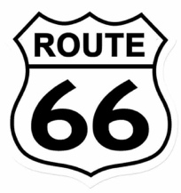
Name ___________________________________________ Grade ______________
Address _______________________________________________________________
City ______________________________________________________
State __________________________ Zip Code ________________
Phone _______________________________
E-mail address: _________________________________________________________
School District __________________________________________________________
School ________________________________________________________________
Name of your submission _________________________________________________
Category (check only 1)
_______ Art Work _______ Photograph
_______ Craft _______ Interview
_______ Performance _______ Music
_______ Video _______ Multimedia
_______ Other

Art work, photographs, and crafts need to be physically submitted to the podcast at 3840 Taylortown Road, Furlong, PA 18925. Physical entries will not be returned back to applicants unless return postage is provided. Please contact Route 66 Podcast with any questions at Route66Podast@Gmail.com. Be sure to listen to the Route 66 Podcast for latest announcements associated with the Route 66 Podcast Scholarship program and ideas based on past episodes.
By submitting a Route 66 Podcast Scholarship entry, I attest that I have personally created this submission.
Print Name _____________________________________
Signature _______________________________________ Date _________________

- Please check here if you are a parent submitting and signing an entry for a youngster in grades K – 12.

